Velociraptor Demo

Go to this link and download the exe
https://docs.velociraptor.app/downloads/
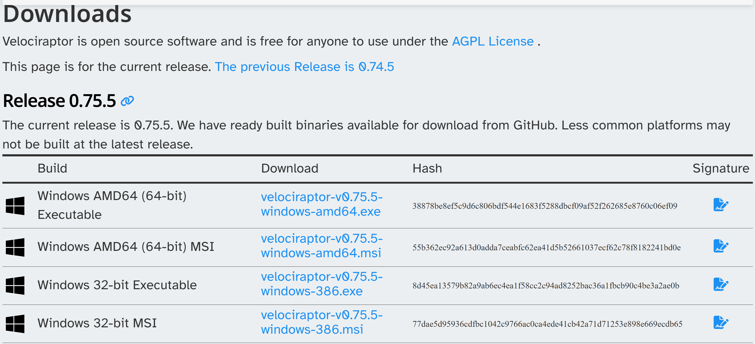
Figure 1 download the Windows AMD64 Executable
Figure 2 Make the server config
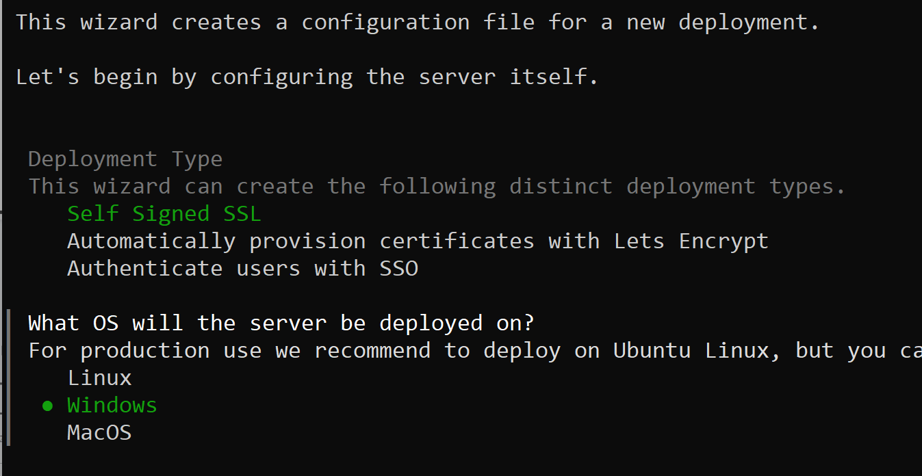
Figure 3 Pick Self Signed SSL and windows
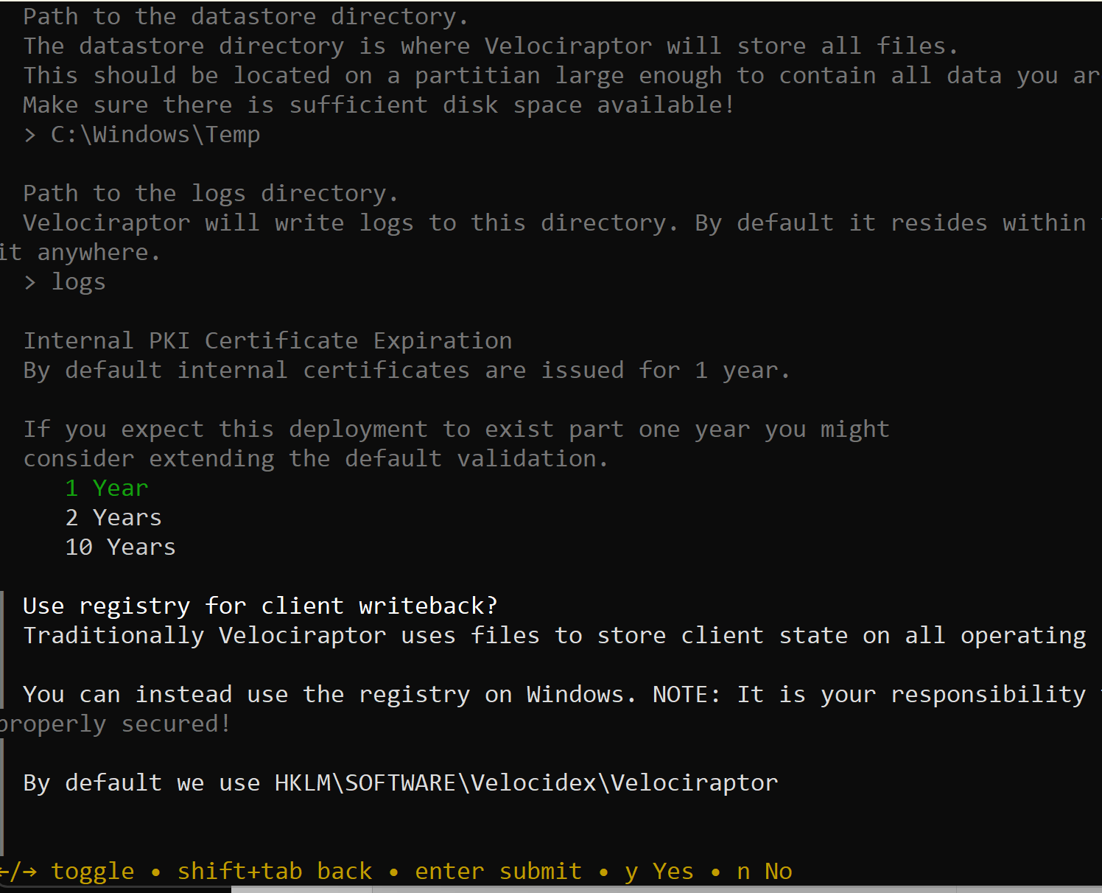
Figure 4 Leave everything as default
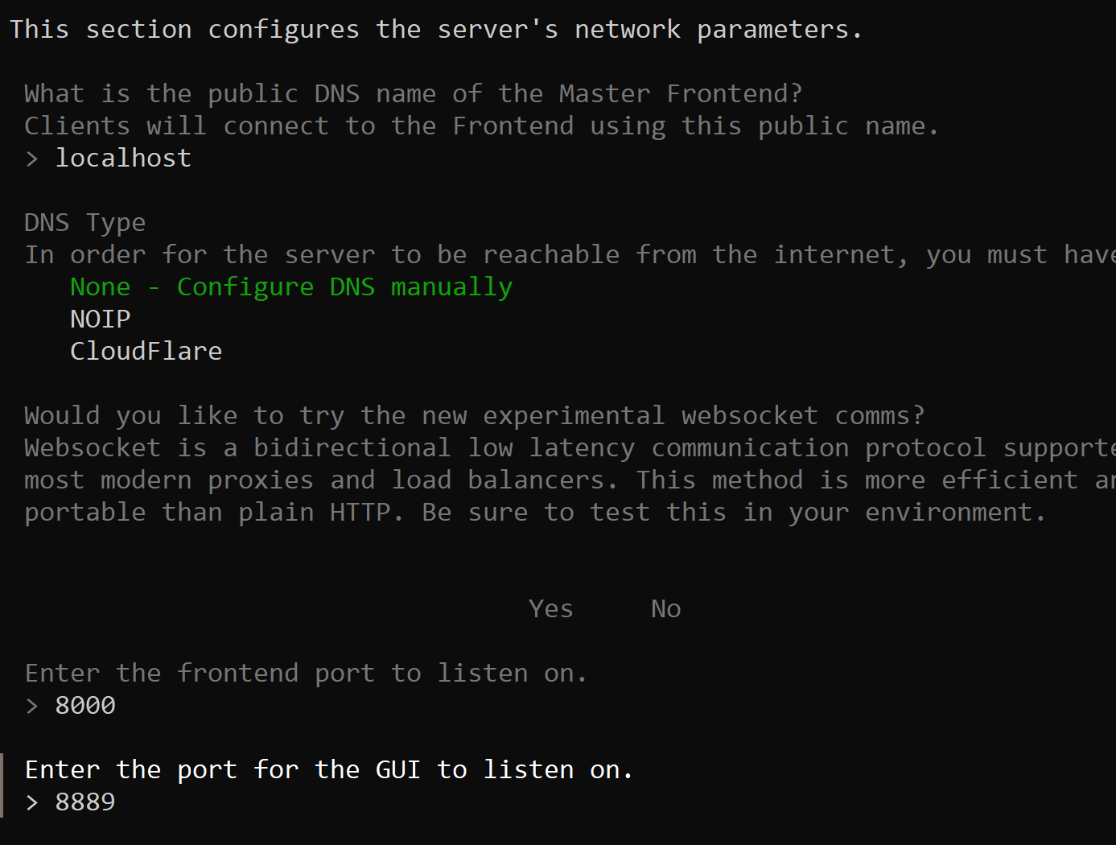
Figure 5 Keep default settings
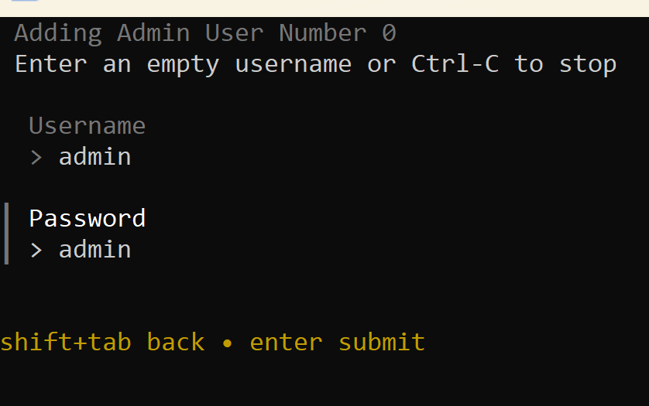
Figure 6 Add an administrator user
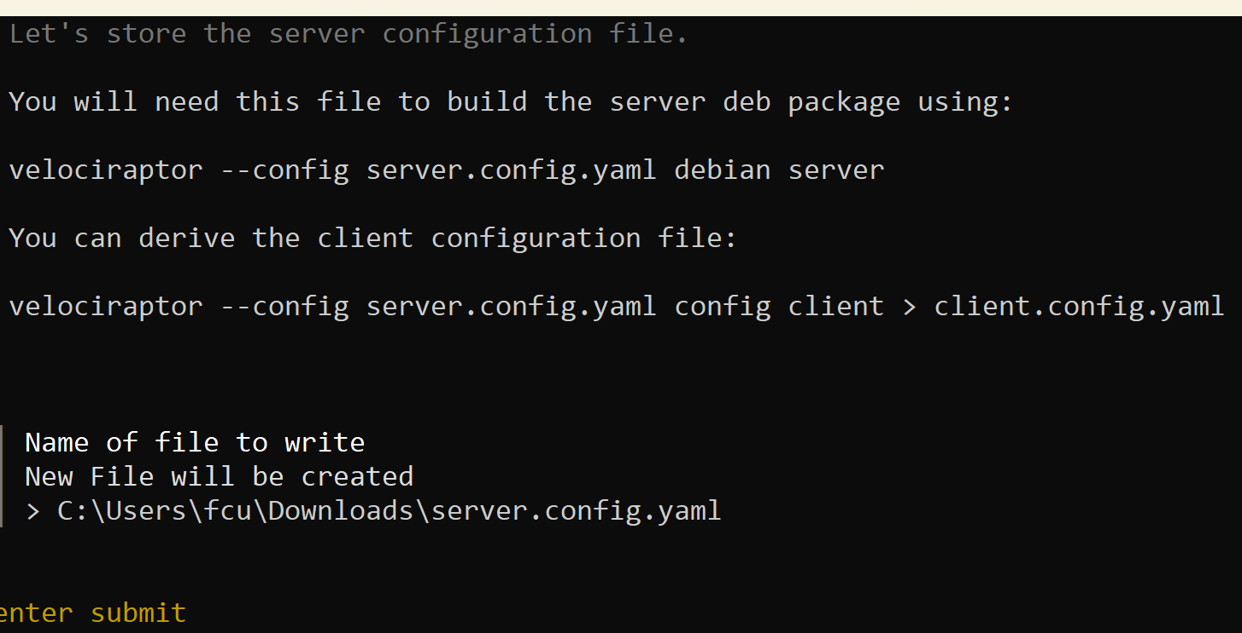
Figure 7 Is to make the server.config.yaml
Figure 8 Install velociraptor as a service
Figure 9 Start the service
Figure 10 Add a user
.\velociraptor-v0.75.6-windows-amd64.exe --config server.config.yaml frontend -v
Figure 11 Check the front end is working
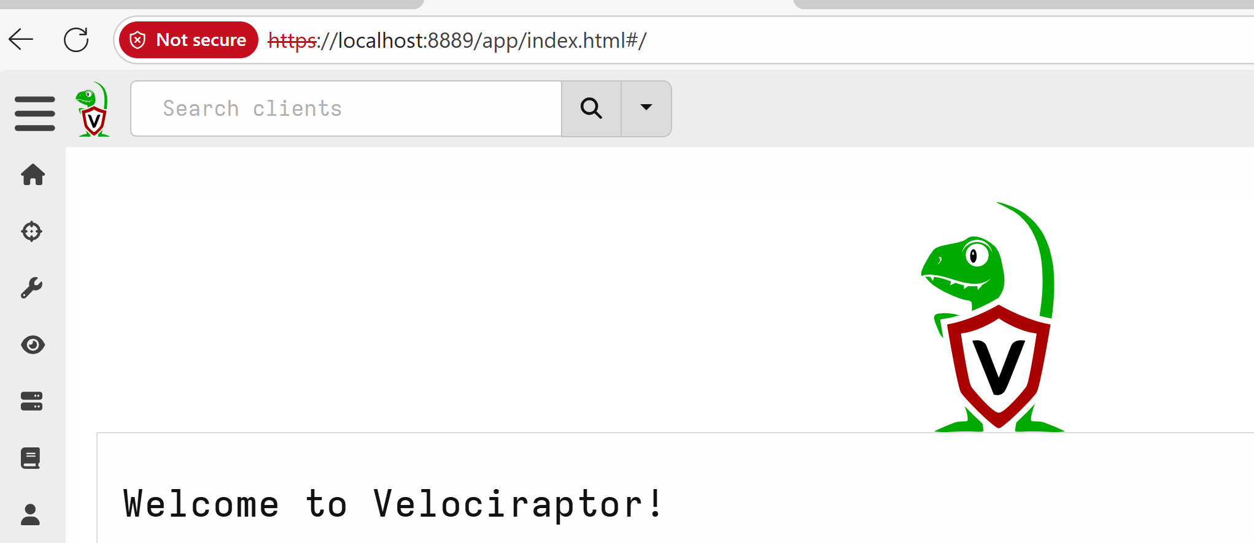
Figure 11 Go to the Velociraptor interface
Figure 12 Generate the client.config.yaml file
Figure 13 Repacked the client executable
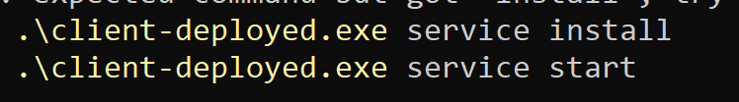
Figure 14 Install and start the service

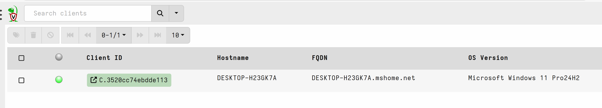
Figure 15 Check the Client has been installed

